1. Find the Eno, Ename, salary of the employee whose salary is greater than 4,000.

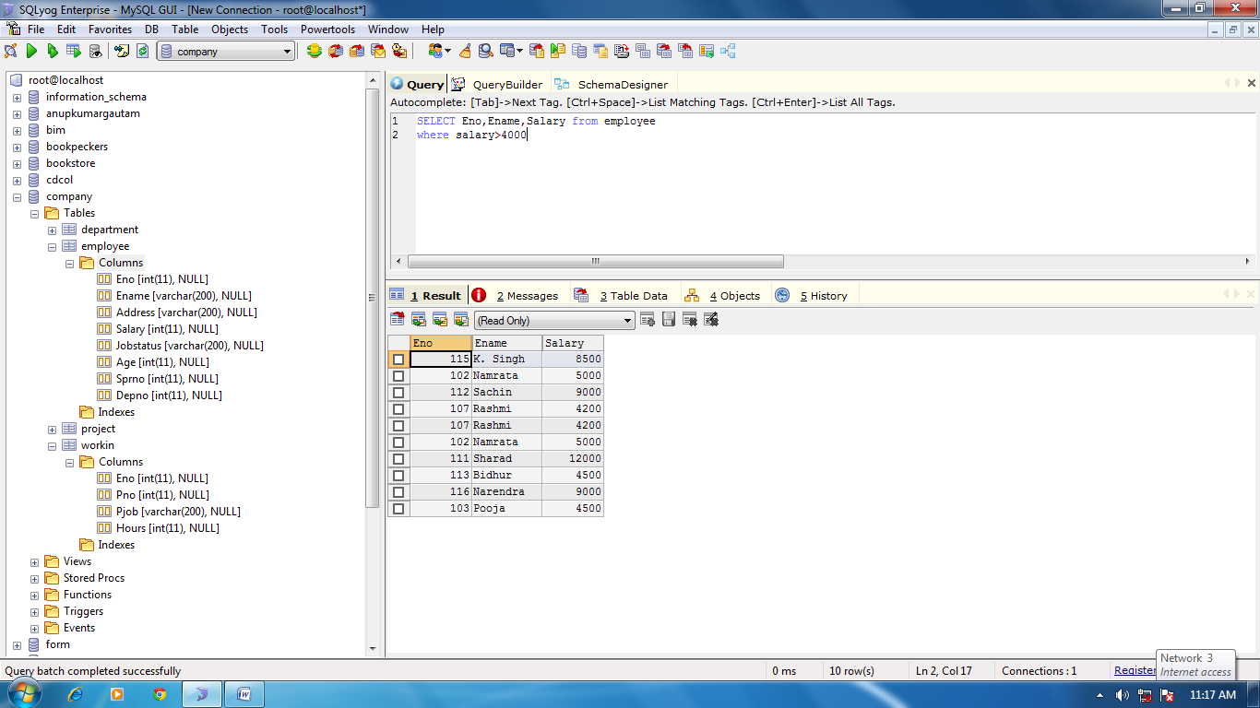

1. Find the Eno, Ename, salary of the employees whose salary is greater than 5,000 and job status is professor

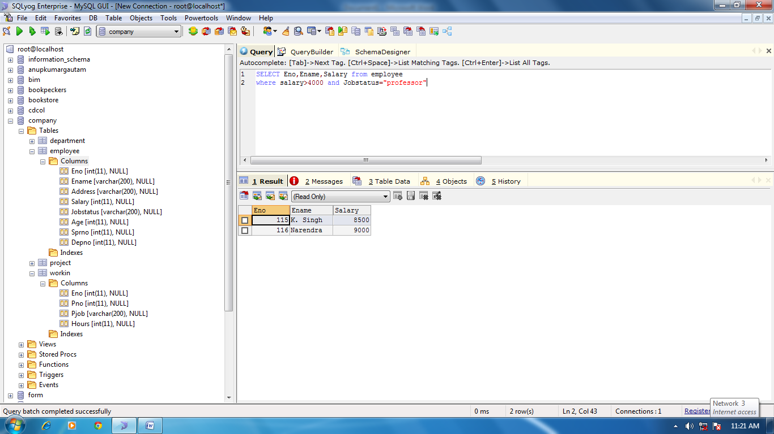

1. Removing Duplicates

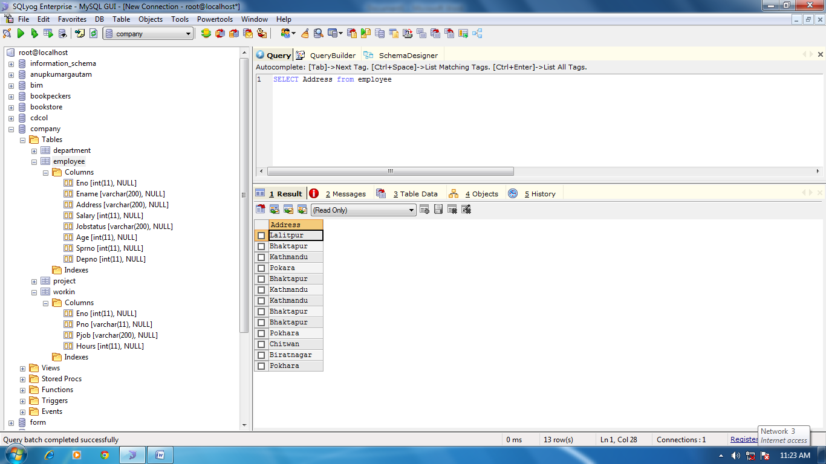

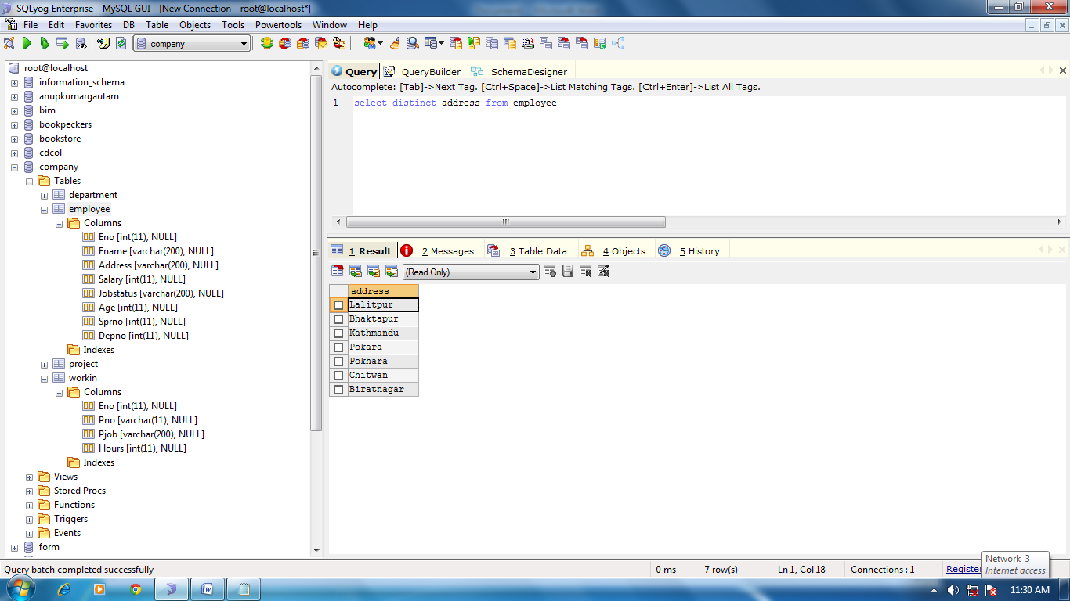

1. Find the Eno, Ename , age and salary of the employee where age is between 24 and 28

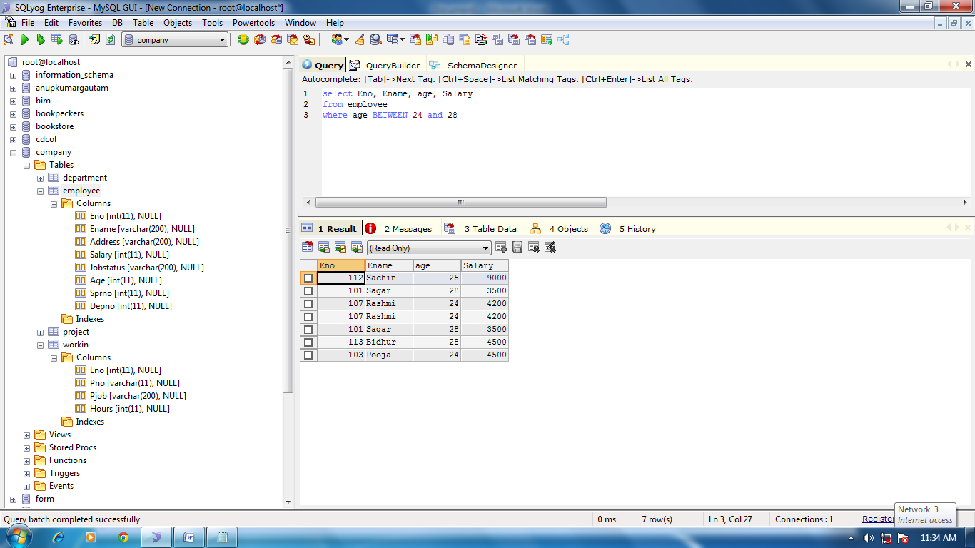

1. String Operations

* ‘ABC%’ : All strings that start with ABC e.g. ABC, ABCD
* ‘%XYZ’ : All strings that end with XYZ e.g. WXYZ and ZZXYZ
* ‘%AN%’ : All string that contain the pattern AN anywhere e.g. LOS ANGLES and SAN FRANCISCO

Find the Eno, Ename whose starting letter “Sa”

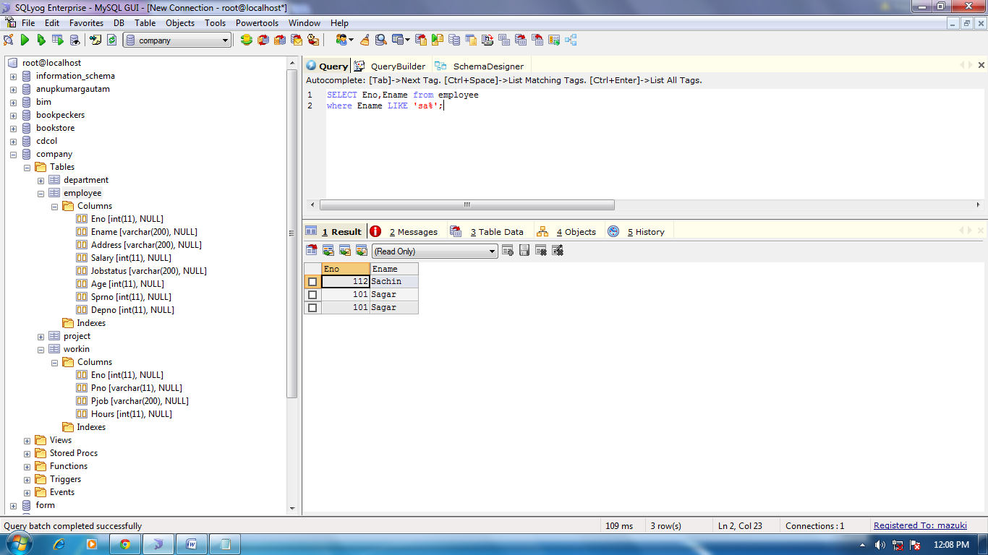

1. List all the employees with their project name

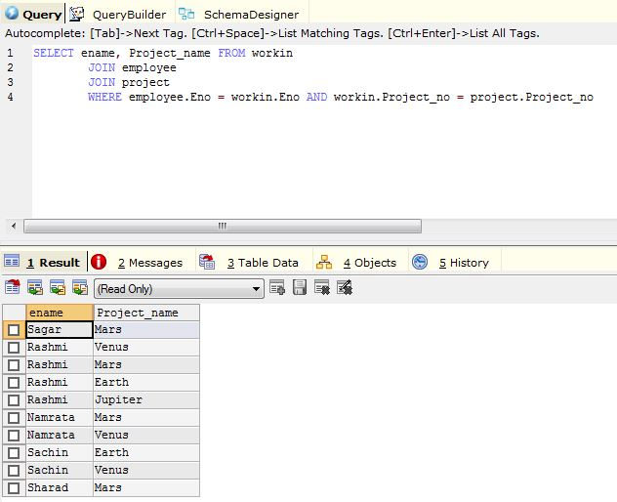

1. List name of all employee and their salary who are working in projects mars or venus
2. List name of all employee and their salary in project earth and venus
3. List name and address of all the employees who work in